Pokhara University

Level: Bachelor | Semester – Spring | Year : 2005
Programme: BE |  | Full Marks: 100
Course: Electronic Circuits I |  | Time : 3hrs.

Candidates are required to give their answers in their own words as far as practicable.
The figures in the margin indicate full marks.

Attempt all the questions.

 | - What is a multistage amplifier? Why it is necessary? Draw two stage R-C coupled BJT amplifier and briefly explain the effect of coupling capacitors on its gain.  - For the circuit given below, find  - r_{in} _{(stage)}  - r_{o(stage)}  - voltage gain 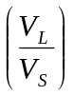  - ac output voltage if V_{S} = 1mv rms.  Assume 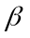=150, r_{e} = 20, r_{c} =  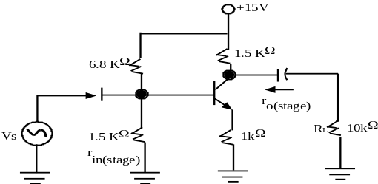 | 8  7
 | - For the circuit given below, derive the expression of upper cut off frequency due to C_{A}. in which condition upper cut off frequency tends to infinity?  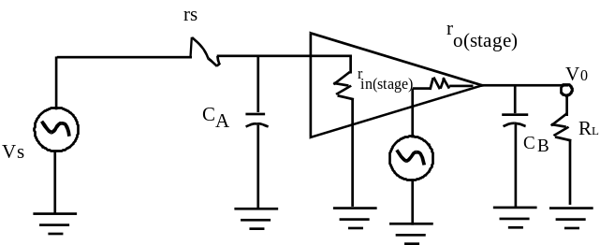  - An audio amplifier has a lower cut off frequency of 20 HZ and an upper cut off frequency of 20 KHz. The amplifier delivers 24 watt to a 10 load at 2 KHz. What is the rms load voltage at 3 KHz?  - Show that the maximum possible efficiency of Transformer Coupled Load Class A amplifier is only 50%. | 5+2  3  5
 | - Negative feedback reduces gain but extends Bandwidth of an amplifier. Verify it.  - An amplifier has an open loop gain of 35 and feedback ratio of 0.2. If the open loop gain changes by 30% due to temperature, find out the changes in closed loop gain. | 8  7
 | - Explain the principle of RC-phase shift oscillator with suitable diagram. Derive the expression of frequency of oscillation.  - What are inputs offset and output offset voltages of an op-Amp? Briefly explain monostable multivibrator.  OR  - Draw emitter follower circuit. Derive its voltage gain, input Impedance and output Impedance. | 8  7
 | - What are the main characteristics of an ideal op-Amp? Op-Amp can be used as a subtractor. Explain with suitable circuit diagram.  OR  a) What are the various types of negative feedback configuration? Derive the expression of input resistance for current series feedback.  - Describe the basic principle of R-2R ladder type pe D/A converter. How this type of converter is more practical compared to the weighted resistance D/A converter/ explain.  OR  - What do you mean by LC tuned oscillator? Briefly discuss Hartley and Colpitt oscillator. (Derivations are not necessary). | 3+5  7
 | - Draw full wave bridge rectifier circuit and briefly explain its working principle. What is PIV?  - In figure overlaid V_{in} = 20V, R = 200 and V_{Z} = 10V. If V_{BE} = 0.6V, find  - V₀  - The collector to emitter voltage of the transistor  - The current in the 200resistor  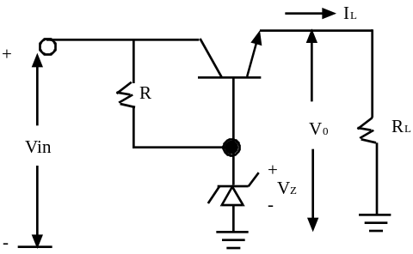 | 8  7
 | Write short notes on (Any Two):  - Schmitt Trigger  - Flash type ADC  - Crystal oscillator  - Complementary symmetry Class B push pull amplifier | 2x5

